CSA0501-Database management systems
Lab Experiments
Name: K. Tejaswi Reg No: 192525407

Ex. No: 5 SELECT with various clause – WHERE, pattern matching

Aim: To perform SQL SELECT operations using the WHERE clause and pattern matching on the imports table.
Procedure:
- Select the imported_management database.
- Use the SELECT statement to retrieve records from the imports table.
- Use the WHERE clause to filter records based on conditions.
- Use the LIKE operator for pattern matching.
- Use % as a wildcard to match zero or more characters.
- Execute the queries and observe the results.
SQL Queries:
WHERE:
USE imported_management;
SELECT *
FROM imports
WHERE price > 500;
LIKE:
SELECT *
FROM imports
WHERE product_name LIKE 'S%';
SELECT *
FROM imports WHERE country LIKE 'S%';
OUTPUT:
SELECT:
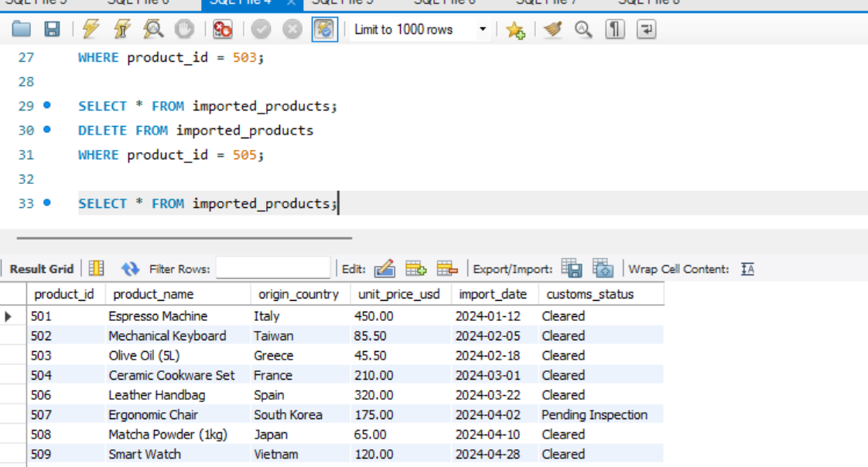

WHERE:
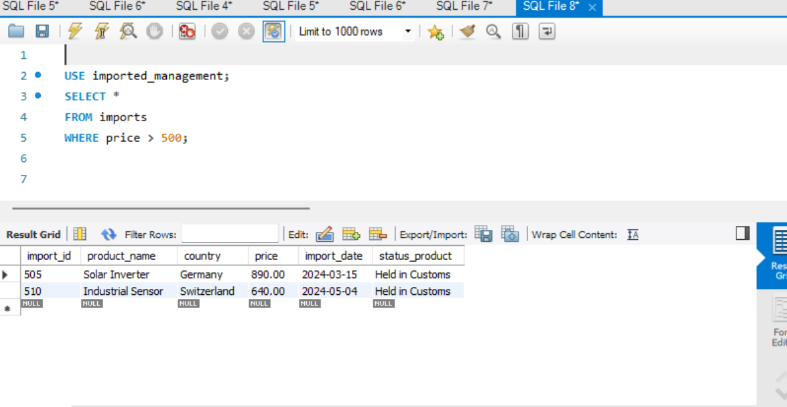

LIKE:
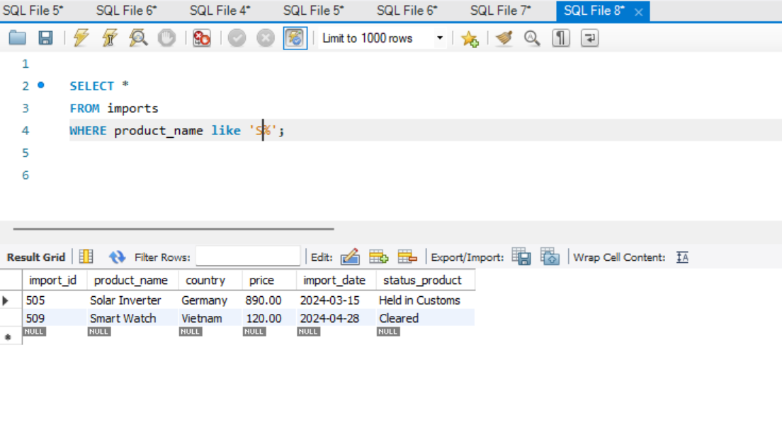

Result:
The SELECT statement was successfully executed using the WHERE clause and pattern matching. The required records were retrieved from the imports table based on the specified conditions and patterns.

Ex.No:6 SELECT with various clause – BETWEEN, IN, Aggregate function

Aim: To perform SQL SELECT operations using BETWEEN, IN, and Aggregate Functions (COUNT, SUM, AVG, MAX, MIN) on the imports table and retrieve summarized information from the database.
Procedure:
- Open MySQL Workbench and connect to the MySQL server.
- Select the database imported_management.
- Use the imports table containing import details.
- Execute queries using the BETWEEN clause to retrieve records within a range.
- Execute queries using the IN clause to retrieve records matching multiple values.
- Use aggregate functions such as COUNT(), SUM(), AVG(), MAX(), and MIN() to perform calculations on table data.
- Observe and verify the output.
SQL Queries:
Between:
SELECT *
FROM imports
WHERE price BETWEEN 100 AND 500;
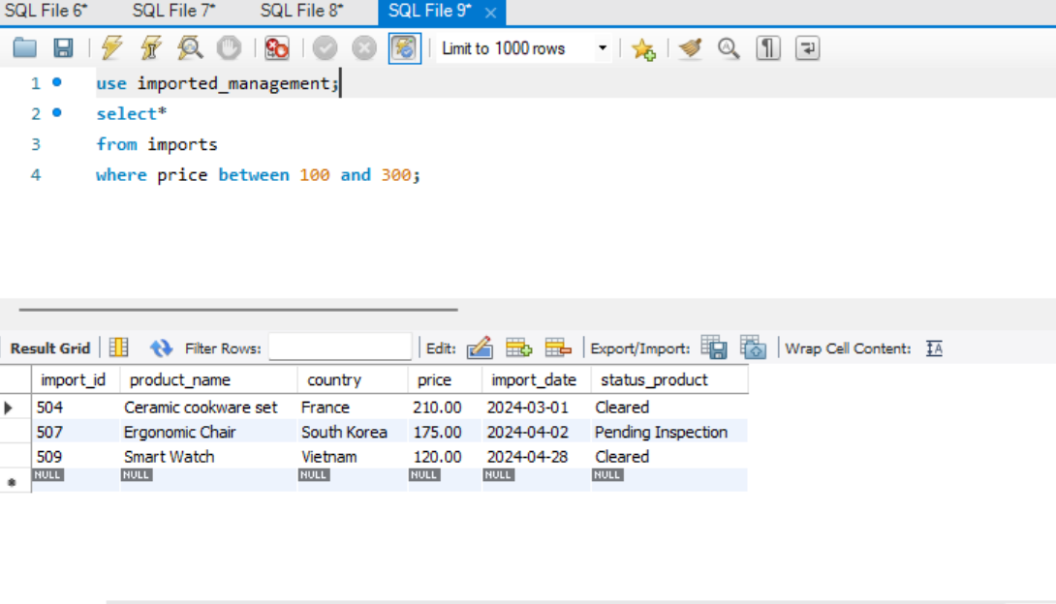
IN:
SELECT *
FROM imports
WHERE status_product IN ('Cleared', 'Held in Customs');
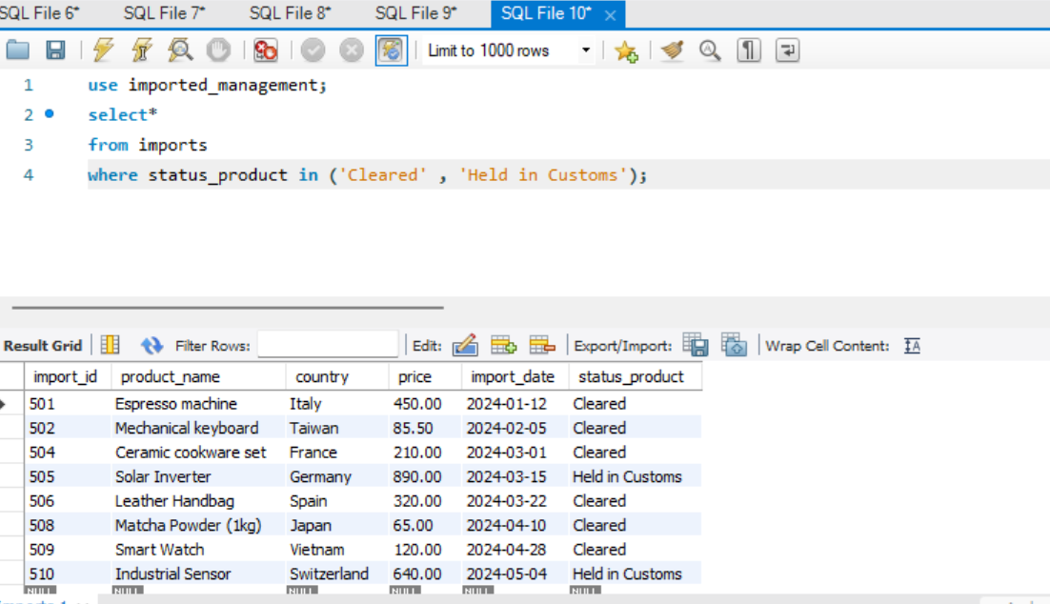
Aggregate functions:
USE imported_management;
SELECT COUNT(*) AS Total_Products
FROM imports;
SELECT SUM(price) AS Total_Price
FROM imports;
SELECT AVG(price) AS Average_Price
FROM imports;
SELECT MAX(price) AS Highest_Price
FROM imports;
SELECT MIN(price) AS Lowest_Price
FROM imports;
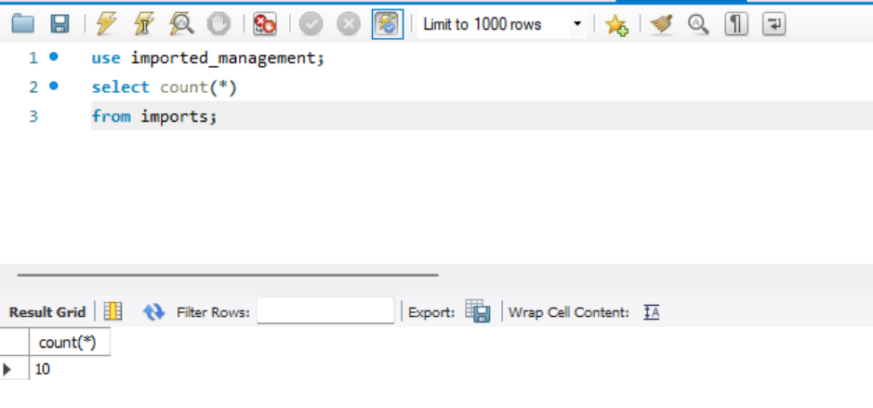
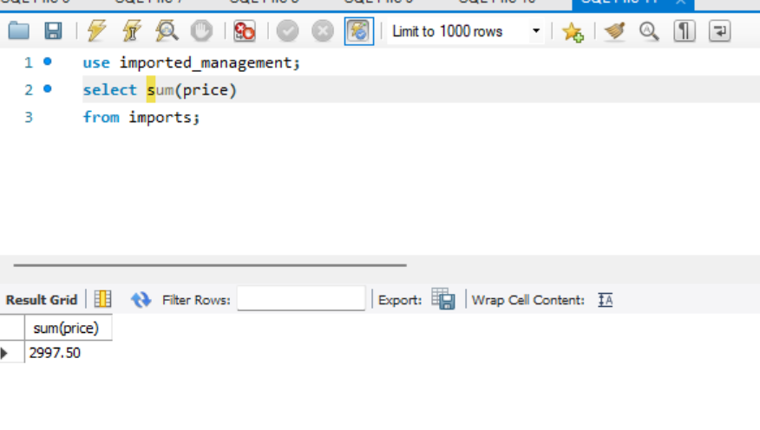
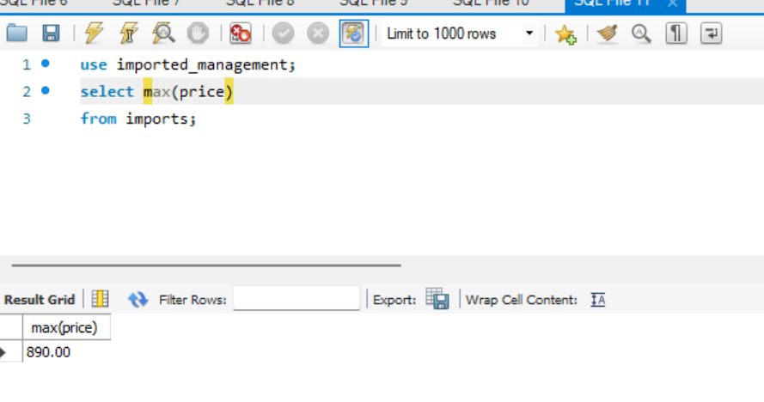
Result:
The query calculates the total number of products, total price, average price, highest price, and lowest price from the imports table.
Ex. No:7 SELECT with various clause – GROUP BY, HAVING, ORDER BY

Aim: To perform SQL queries using the GROUP BY, HAVING, and ORDER BY clauses on the imports table to group, filter, and sort import records.
Procedure:
- Select the imported_management database.
- Use the existing imports table.
- Apply GROUP BY to group records based on a particular column such as country or status_product.
- Apply aggregate functions such as COUNT() and SUM().
- Use HAVING to filter grouped results.
- Use ORDER BY to arrange the output in ascending or descending order.
- Execute the queries and observe the results.
SQL Queries:
GROUP BY:
SELECT country, COUNT(*) AS total_imports
FROM imports
GROUP BY country;
HAVING:
SELECT status_product, SUM(price) AS total_price
FROM imports
GROUP BY status_product
HAVING SUM(price) > 500;
ORDER BY:
SELECT import_id, product_name, country, price, status_product
FROM imports
ORDER BY price DESC;
Outputs:
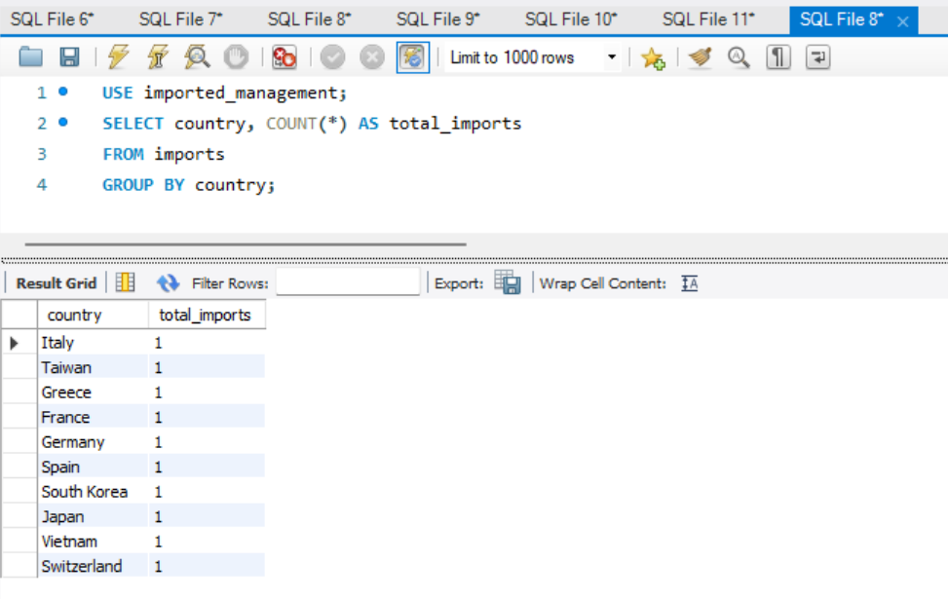

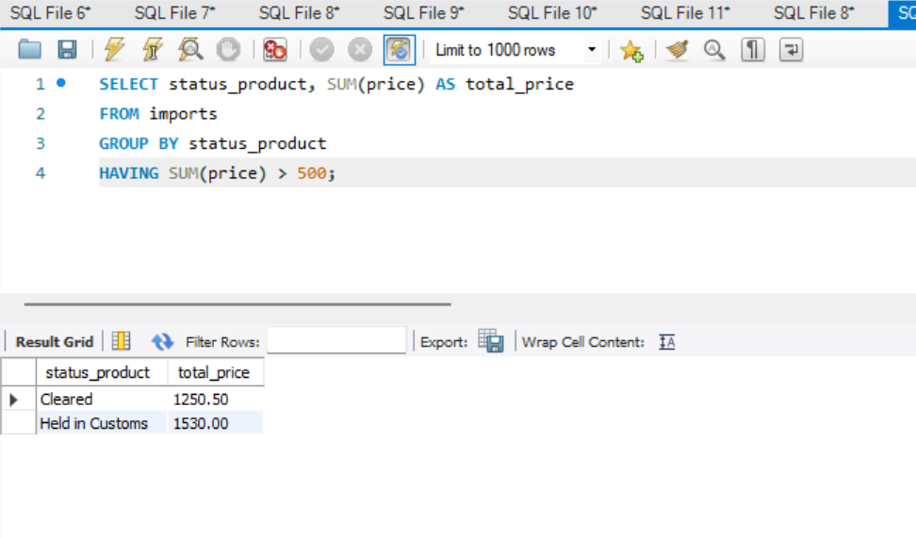

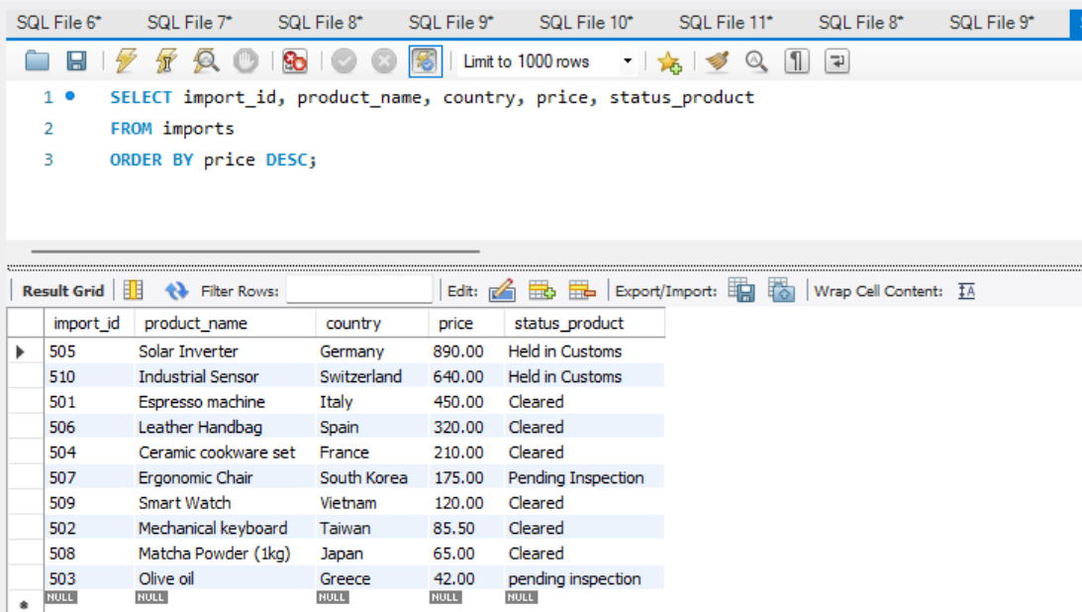

Result:
The GROUP BY, HAVING, and ORDER BY clauses were successfully executed on the imports table of the imported_management database. The records were grouped based on import status, filtered using aggregate conditions, and arranged in descending order of total price.

Ex. No: 8 Query with Joins – EquiJoin, InnerJoin, OuterJoin

Aim: To perform different types of SQL joins such as EquiJoin, Inner Join, and Outer Join on related tables and retrieve combined data from multiple tables.
Procedure:
- Create two related tables with a common column.
- Insert sample records into both tables.
- Use EquiJoin to combine rows based on equality of the common column.
- Use Inner Join to retrieve only matching records from both tables.
- Use Left Outer Join to retrieve all records from the left table and matching records from the right table.
- Use Right Outer Join to retrieve all records from the right table and matching records from the left table.
- Execute the queries and observe the results.
SQL Queries:
EquiJoin:
SELECT STUDENT.StudentID,
STUDENT.StudentName,
DEPARTMENT.DepartmentName
FROM STUDENT, DEPARTMENT
WHERE STUDENT.DepartmentID = DEPARTMENT.DepartmentID;
Inner Join:
SELECT STUDENT.StudentID,
STUDENT.StudentName,
DEPARTMENT.DepartmentName
FROM STUDENT
INNER JOIN DEPARTMENT
ON STUDENT.DepartmentID = DEPARTMENT.DepartmentID;
Left Outer Join:
SELECT STUDENT.StudentID,
STUDENT.StudentName,
DEPARTMENT.DepartmentName
FROM STUDENT
LEFT JOIN DEPARTMENT
ON STUDENT.DepartmentID = DEPARTMENT.DepartmentID;
Right Outer Join:
SELECT STUDENT.StudentID,
STUDENT.StudentName,
DEPARTMENT.DepartmentName
FROM STUDENT
RIGHT JOIN DEPARTMENT
ON STUDENT.DepartmentID = DEPARTMENT.DepartmentID;

Output:
